Setting up your Patchs account
Visit Eastham Group Website: https://easthamgrouppractice.co.uk/
Select the PATCHS banner
Select the green box “Submit a PATCHS”
You will then see the below screen – select the box “Contact my GP practice” highlighted red below:
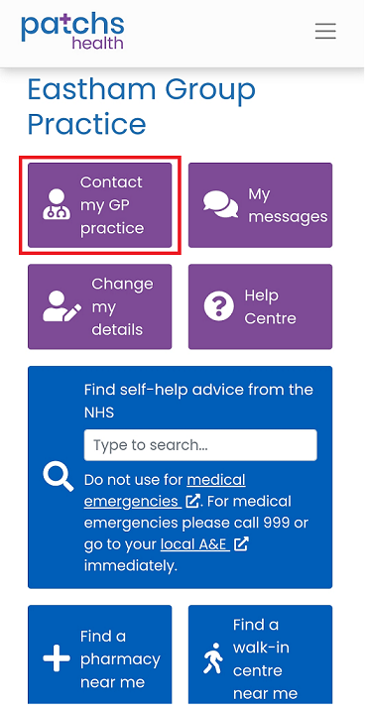
Please read the following login screen and choose how you want to login:
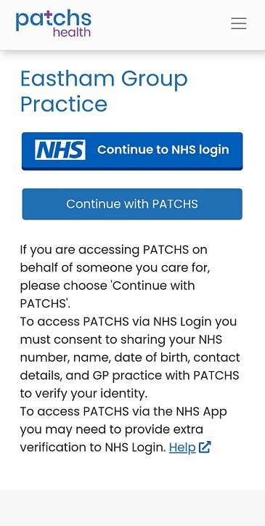
If you “continue with Patchs” you will see the below screen, here you can create an account we advise you create an account to make it easier for you, here are some of the benefits of registering for a patchs account:
- Not having to keep entering your details each time you use Patchs.
- Your medical information being safer because its password protected.
- Being able to track the progress of your requests.
- Easily seeing if your GP practice is trying to contact you.
- Viewing past conversations, you've had with your GP practice.
- Being able to submit requests on behalf of people you care for.
– please see below highlighted red:

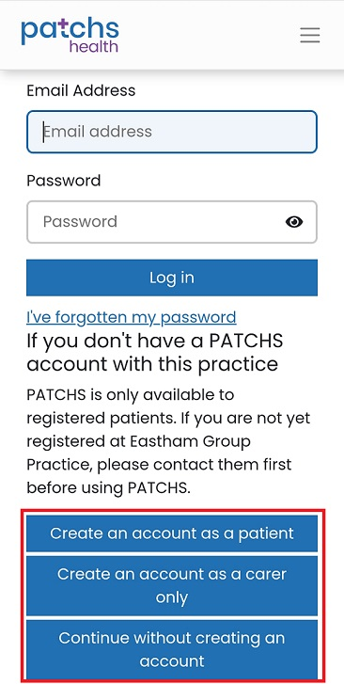

For further support using Patch’s please visit their website https://help.patchs.ai/hc/en-gb/categories/360005779313-Patients

